# Exercise: Graph Design (Geo)

In this assignment, you have to design visualization solutions for questions related to the AidData dataset. This dataset contains information about financial transactions for aid purposes between two countries. Given the data structure and analytical questions presented below, your goal is to sketch views that would help an analyst to obtain the answer for those questions.

## Data

In the AidData dataset, each row represents a financial transaction between two countries. The dataset contains the following attributes:

* **Year:** year of the commitment
* **Donor:** country providing the financial resource
* **Recipient:** country or organization receiving the money
* **Commitment Amount:** the total amount of financial resources provided
* **Coalesced Purpose Name:** the purpose of the transaction

Below is an example of the data:

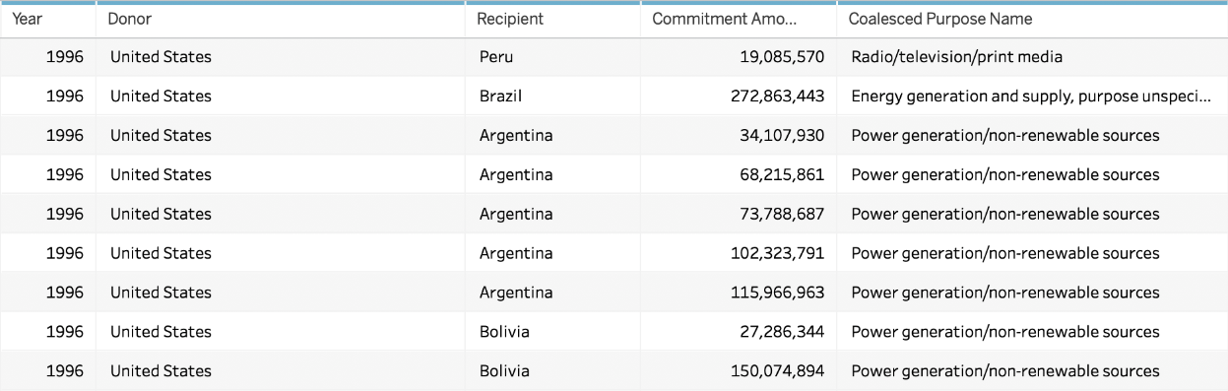

*\*Note: The full dataset has many more columns and it also includes international organizations other than countries. The description here focuses only the attributes and entities (countries) relevant for the assignment.*

You can find a (simplified and reduced) copy of the data here:

<https://drive.google.com/open?id=1YiuHdfZv_JZ-igOemKJMRaU8dkucfmHxOP6Od3FraW8>

You can find the full dataset with descriptions here:

<https://www.aiddata.org/data/aiddata-core-research-release-level-1-3-1>

## Goal

## Your goal is to create 3 independent visualizations of the same data set, each one with the intent of answering the questions stated below. For each numbered visualization, you should be able to create a data visualization that answers **all** of the questions specified.

These are the 3 visualizations you should create.

* **Visualization 1:** How do the countries compare in terms of how much they receive and donate from other countries? Are there countries that donate much more than they receive or receive much more than they donate?
* **Visualization 2:** Do the countries that receive or donate the most tend to cluster around specific geographical areas of the world? Are there neighboring countries that have radically different patterns in terms of how much they receive vs. how much they donate?
* **Visualization 3:** Are there any major differences in how the top 5 most frequent purposes of disbursements distribute geographically in terms of countries that receive donations? Are there countries that tend to receive more of certain types of donations than others?

## Instructions

For this assignment, your goal is to come up with effective visualization designs to answer the questions posed and to communicate their answers found in the data.

You have to submit the following:

1. Submit one or more (hand-drawn) sketches that show your thinking (do not use Tableau or other tools). The sketches can contain multiple solutions. If your sketch contains more than one solution you have to describe pros and cons of each one and explain which one you decided to implement and why. If you submit only one sketch then add only a justification for your design and why you think it works for the problem assigned.
2. Submit a screenshot of the visualization you developed in D3.
3. Submit your D3 code in a separate file.